Git & GitHub Challenges:
1.Resolve Merge Conflicts:
Create a merge conflict intentionally (two users editing the same line).
Resolve the conflict and push the changes.
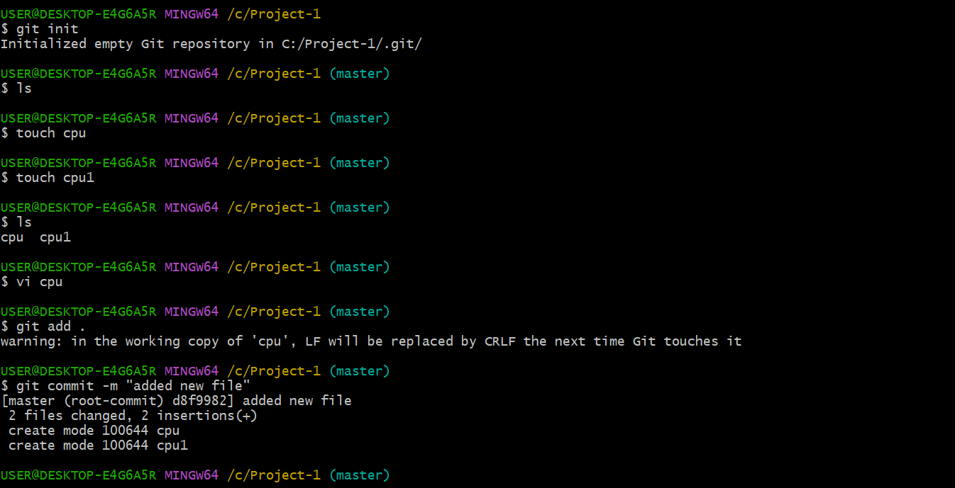
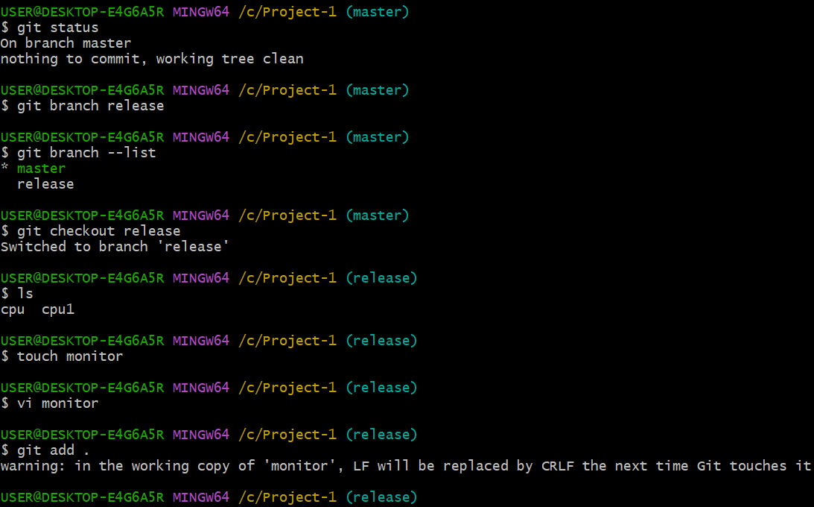
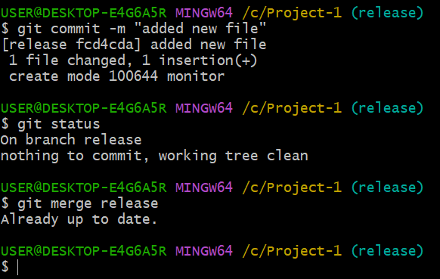

2.Recover Deleted Branch:
Delete a local branch and then recover it using the reflog.
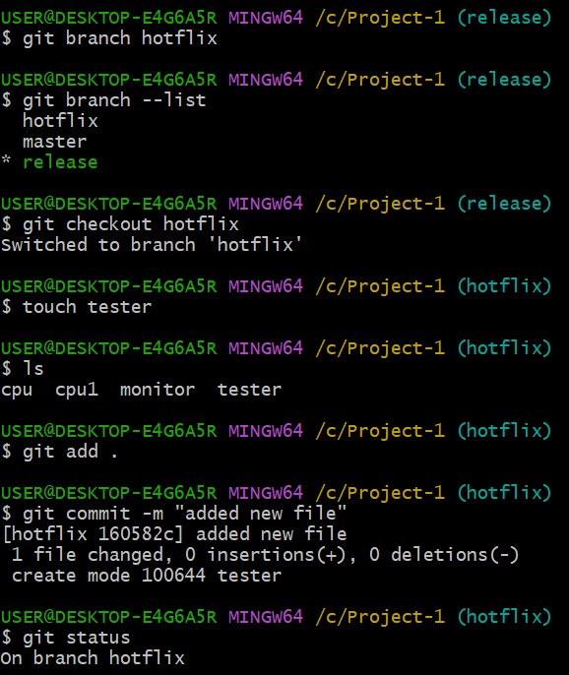
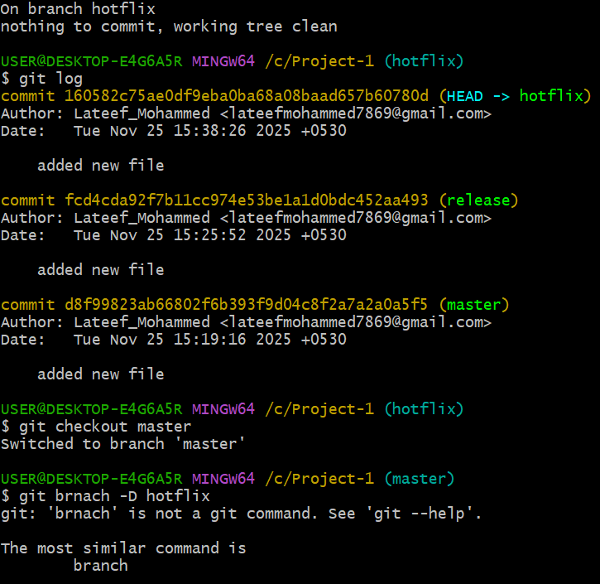
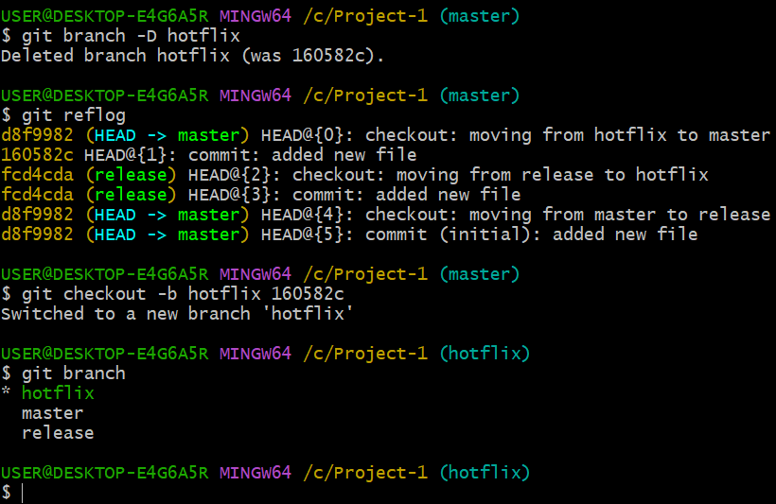
3. Undo Wrong Push:
Push a wrong commit to GitHub, then undo it without losing history.
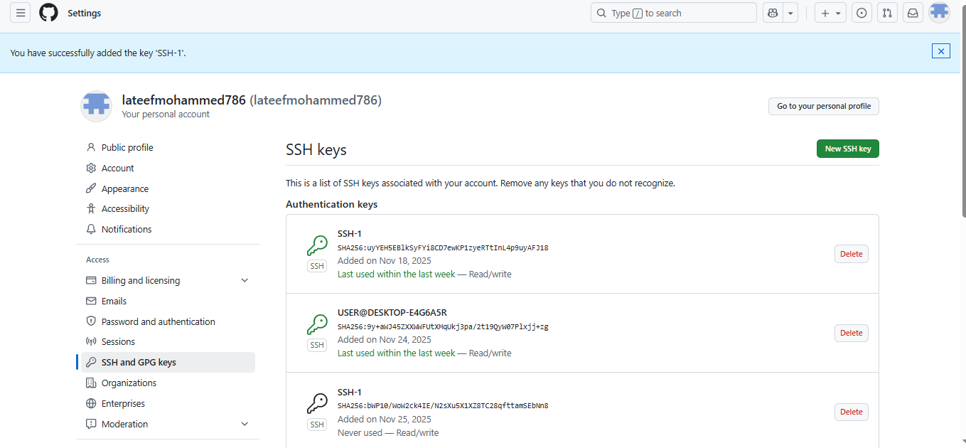
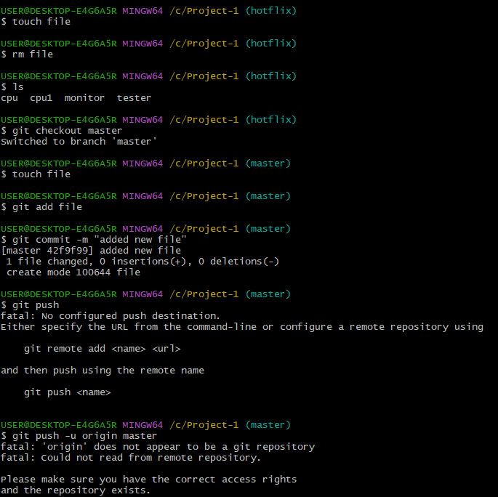
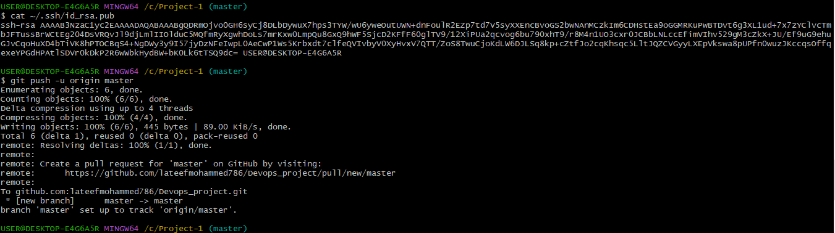
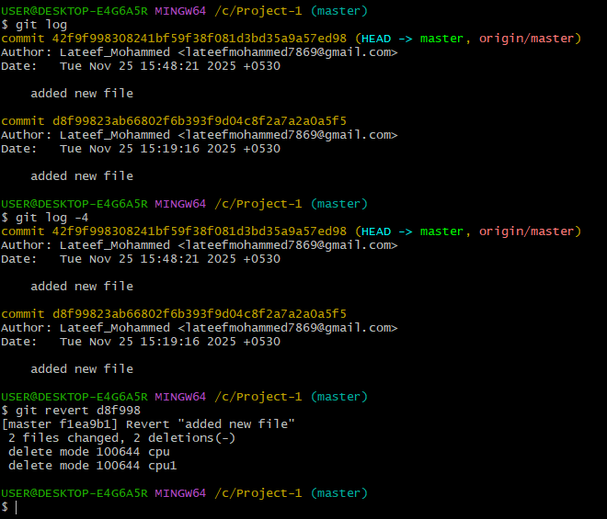

4. Amend a Commit:
Make a commit, then add a missing file to it using git commit –amend.
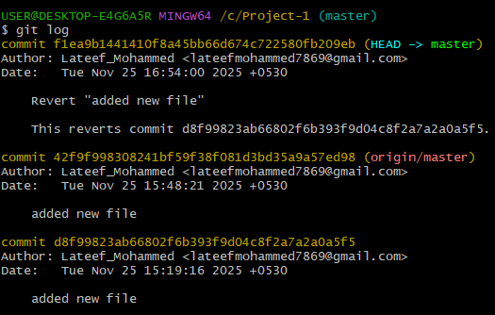
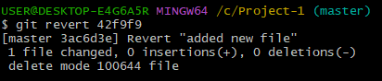
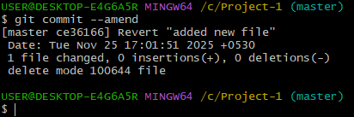

5.Cherry-pick a Commit:
Take a specific commit from one branch and apply it to another branch.
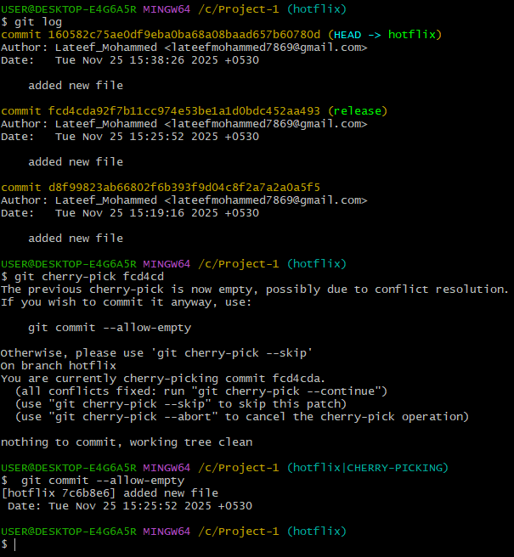

6.Interactive Rebase:
Reorder and squash multiple commits into a single clean commit.
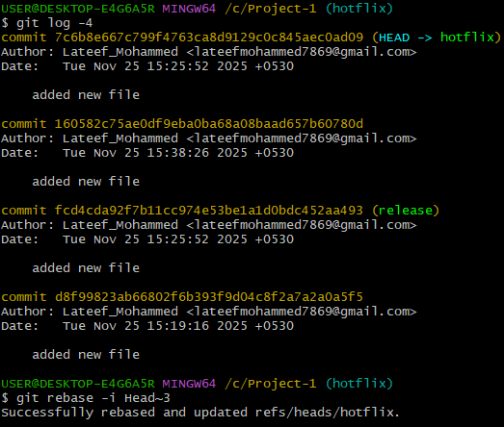
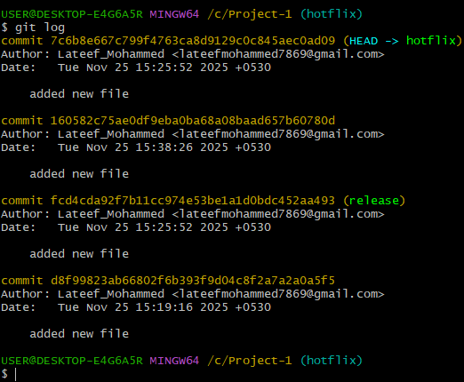

7. Tagging & Release:
Create a version tag (v1.0), push it to GitHub, then delete and restore it.
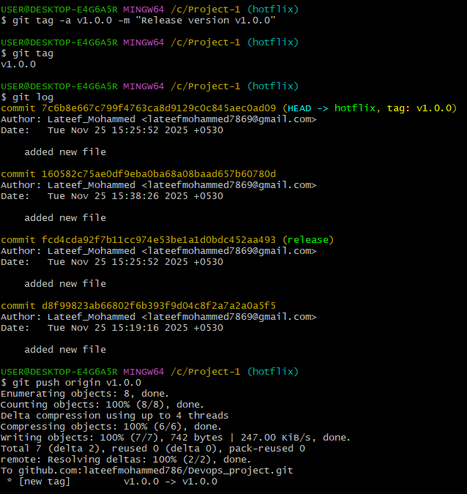
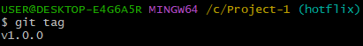
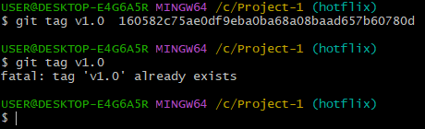

8.Clone with Sparse Checkout:
Clone only a subdirectory of a repo using sparse checkout.
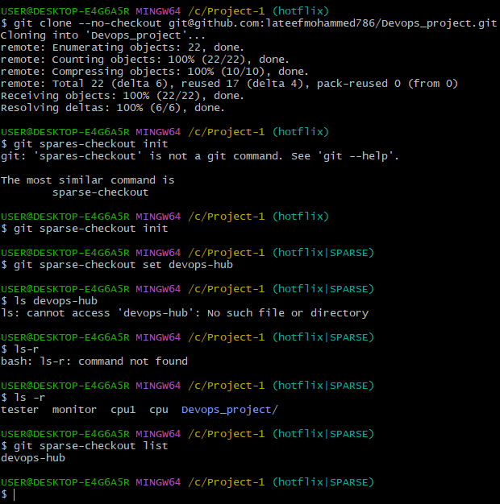
9.Reset vs Revert Challenge:
Demonstrate the difference between git reset --hard and git revert in a repo.
10. Detached HEAD challenge:
Checkout a specific commit (detached HEAD state) and create a new branch from it.
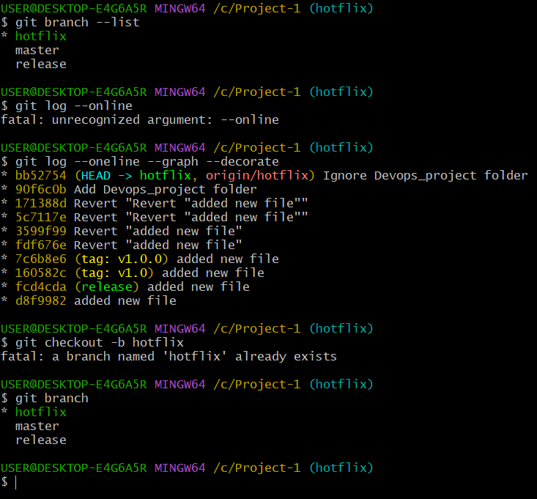

12.Recover Lost Commit:
Commit something, reset hard, and then recover it using git reflog.
